**Autism Friendly Set up Guide**

**Key things to remember during the event:**

* No unnecessary radio use, keep radios at a low volume.
* No Tannoy announcements
* Don’t move trolleys around in public areas to avoid additional noise
* Be patient, calm and kind.
* Use straightforward language – be literal
* Slow down and be concise.
* Be familiar with the Autism Friendly session map and know where quiet spaces and calm corners are.
* Understand that our visitors may not respond to questions as you expect them to, they may not respond at all.
* Be vigilant – if you see someone in distress please ask if there is anything you can do to help/is there anything they need? Would they like to use a quiet space? Even if the answer is no, let them know that they can call on you at any time. Please don’t ignore them. Go back and check – it’s better to be asked too often than not at all.
* Lost Children – they may be non-verbal so be patient.

**Ground floor**

**Queueing System**

There should be no snake system of tensa barriers in place until at least 10:30.

**Ticket desk**

Equipment – Box of ear defenders x6 for loan (box includes cleaning wipes)

Signage – Ear Defenders available to borrow here

Quiet Space box – there is a quiet space box at the ticket desk. It should be moved to the CRA Quiet space area for the event.

This equipment should be available every day at the ticket desk and wiped clean after events and when handed back after single use.

What’s on Guide for the event (approx. 10 copies in A3 for any visual impairments)

Processing tickets – Please use the Autism Friendly buttons and remember carers go free.

**Street**

Directional signage (arrow) to Quiet Spaces in Children Reception Area.

Signs on door of CRA - Quiet Space

**Children’s Reception Area**

Set up 3x partitioned areas along back wall (see photo).

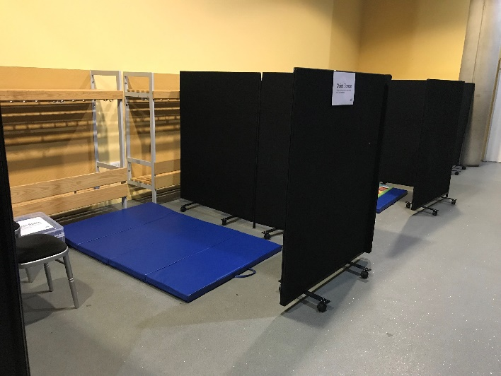

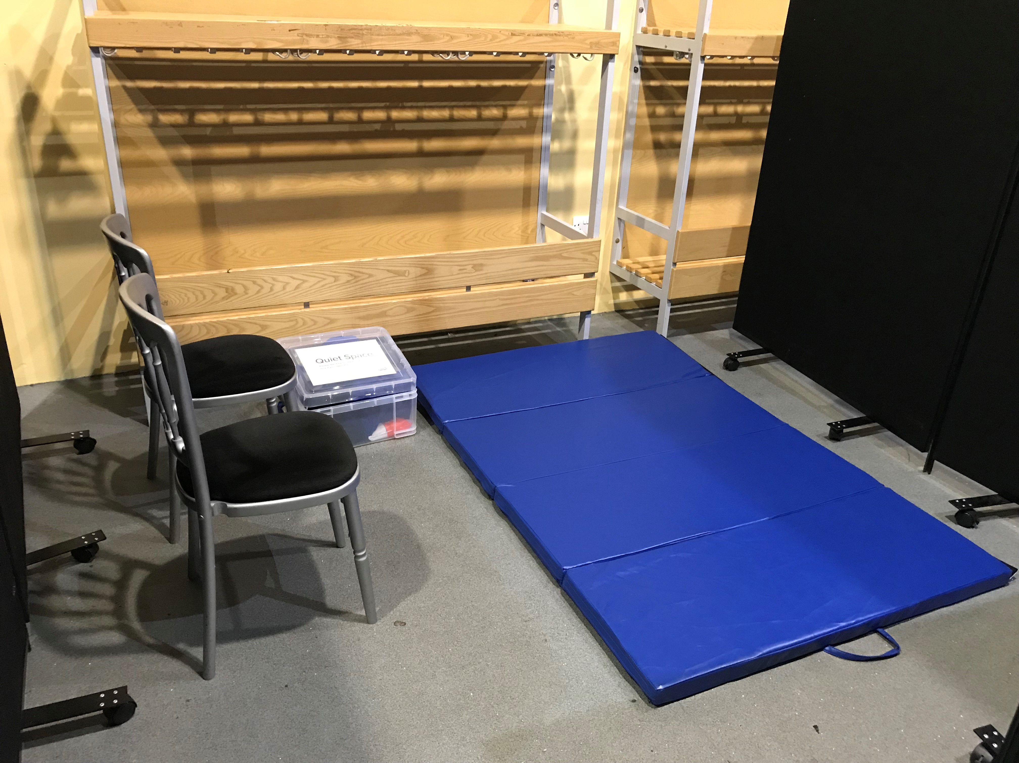

Partition using events boards.

Inside each area should be a blue gym mat.

1-2 chairs

2 of the areas have a box which should be labelled ‘Quiet Space’ and will contain:

1x weighted blanket or shoulder wrap

1x ear defenders

1x bag sensory toys

Cleaning wipes

The third area will only have a bag of sensory toys.

**Take down**

After 11am (preferably no earlier than 11:30) please keep one quiet space available and pack the rest away to accommodate visitors using the cloakroom. At the end of the day please use the cleaning wipes to clean ear defenders, mats and toys before storing. The Quiet Space box stay with FOH for loan, gym mats are stored in the dungeon. Please retain laminated signs for the next event.

**Ground Floor toilets**

**Signage**

Male / Female signs in addition to the gender figures.

Hand Driers not in use – use the dryer covers on all dryers

Please also use bin liners and tape to bag up the driers so they cannot be seen.

**Floor 1**

**Calm Corners**

Space Zone – use event partitions in corner next to the entrance door. This area should have a blue gym mat and a ‘Calm Corner’ box containing either a weighted blanket or shoulder wrap, ear defenders, bag of sensory toys and cleaning wipes. – Please place a Calm Corner sign on the outside of the partition.

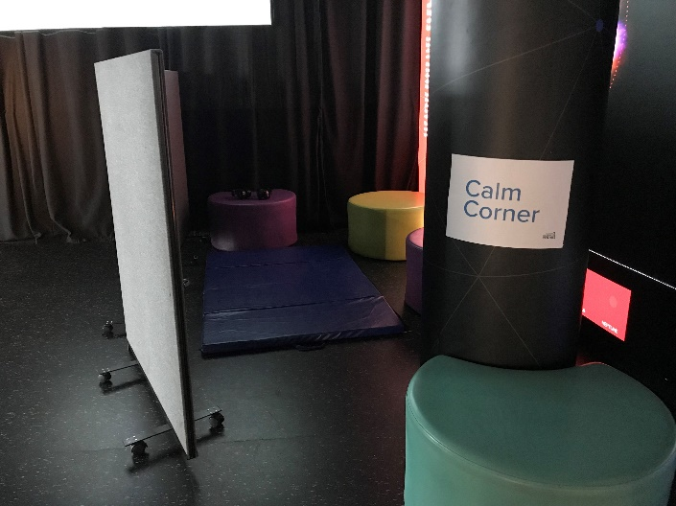

Baby Area – as matting is already available in here, this area only needs a ‘Calm Corner’ box. Please also affix a ‘Calm Corner’ sign to the gate into the baby area covering the Baby Area sign.

These Calm Corner should be removed after 11am (providing it is vacant) and reinstated as normal.

**Big Explorer**

Hand Driers – use the dryer covers on the water exhibit dryers

‘Mind your Head’ sign on the crates

‘Noisy Exhibits Area’ signs on both entrances

**Exhibit Signs**

‘Noisy Exhibits Area’ signs should be placed at both ends of the ‘electricity and magnetism’ section at window side of floor 1.

‘Noisy exhibit, please borrow these ear defenders’ sign on the jumping ring + pair of ear defenders.

‘Warning, this exhibit may affect your balance’ at the entrances to the Ames Room and Wacky salon

**F1 Exhibits out of action:**

Energy Machine

Dancing Trees

Captains Bridge including the Bell

Please remove the jumping ring

**Floor 2**

‘Noisy Exhibit Area’ signs are the entrances to PTF

‘Noisy exhibit, please borrow these ear defenders’ signs at hurricane booth and hydrogen rocket and air compressed rocket exhibits – also supply a pair of ear defenders at each location.

Toilets – please display ‘Male’ ‘Female’ signage

Use the dryer cover on the Lego Dam dryer.

**Floor 3**

Calm Corner located outside the toilets. This area does not need to be partitioned but should have a blue gym mat and a ‘Calm Corner’ box. There should also be a seat (blue bench) but please ensure it is not located next to the drop to the ground floor. This calm corner can stay in place for the day.

Toilets – please display ‘Male’ ‘Female’ signage

**F3 Exhibits out of action:**

Multitasker

**Science Show Theatre**

‘Ear Defenders available to borrow’ – please display sign and check you have the ear defenders box (these should be located in the SST permanently).

**Take down**

At the end of the day please use the cleaning wipes to clean ear defenders, mats and toys before returning them to the dungeon. Please retain laminated signs for the next event.

Signage should be stored with the Quiet Space boxes in the Dungeon.

Please inform Tara of any missing/broken/damaged equipment and if you need more wipes.